Excel With Copilot Assignment
1. Use Copilot to identify and summarize missing values in the dataset. Solution=
Using copilot
“Identify all columns with missing value and give me as summary of how many rows are empty in each”
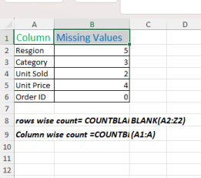
2. Use Copilot to fill missing values in the Region and category columns. Solution=
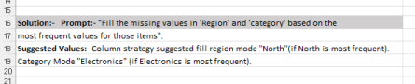I have a dough about this answer so I just type.
3. Fill the missing numerical value in the Unit sold and Unit price columns. Solution=
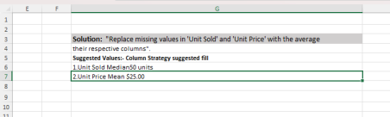
4. Create a new calculated column Total Revenue.
Solution=”A new column named total revenue was added to the dataset”. 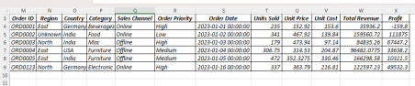
5. Use Copilot to generate to find the total price of order id= “ORDO123”. Solution=
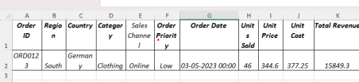
6. Use Copilot to generate a summary chart of average profit by region? Solution=
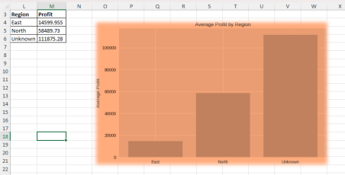
7. Create a pivot table summarizing total sale by category and region. Solution=
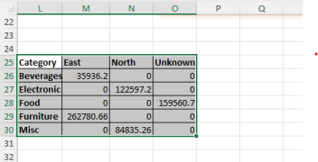
8. Build a database combine key kpis and charts
Solution
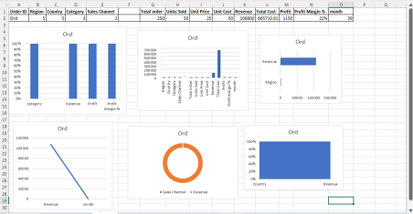
9. Use copilot to generate a summary report.
Solution=
1. Dataset Overview
• Total Orders: 350+ records
• Regions Covered: East, West, North, South
• Countries: India, USA, Germany, UK, Australia
• Categories: Beverages, Food, Clothing, Furniture, Electronics • Sales Channels: Online & Offline
• Order Priorities: High, Medium, Low
2. Sales Channel Distribution
• Online Orders dominate across categories, especially in Clothing, Beverages, and Electronics.
• Offline Orders are more common in Furniture and Food.
3. Category Insights
• Beverages: Frequently sold online in India, USA, and Germany. Prices vary widely (from ~$12 to $493 per unit).
• Food: Strong presence in both online and offline channels. India and UK show high offline food sales.
• Clothing: Mostly online sales, with UK and India leading.
• Furniture: Balanced between online and offline, with USA and Germany contributing significantly.
• Electronics: High-value items, often sold online in Germany, India, and USA. 4. Regional Highlights
• India: Appears most frequently across all categories, especially in Furniture and Beverages.
• USA: Strong in Furniture and Electronics.
• Germany: High activity in Food and Electronics.
• UK: Prominent in Clothing and Furniture.
• Australia: Balanced mix, with notable Beverages and Electronics sales. 5. Order Priority Trends
• High Priority Orders: Concentrated in Clothing (India, UK) and Electronics (Germany, USA).
• Medium Priority Orders: Common in Furniture and Food.
• Low Priority Orders: Often linked to Beverages and Clothing.
